COST PUSH VS DEMAND PULL INFLATION
May-15-20
10:36 AM
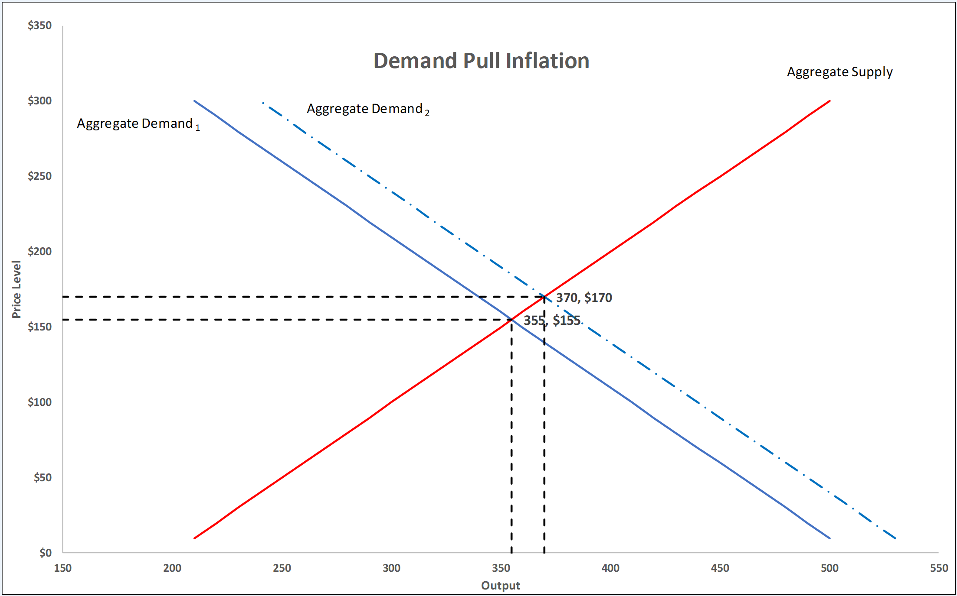
The graph on the right shows the cause of cost push inflation using an aggregate demand (AD) and aggregate supply model¹. The graph contains the aggregate demand curve (blue - downward sloping), the sum of all demand in the economy and the aggregate supply curve (red - upward sloping) The vertical axis measures the price level and the horizontal axis measures the output (GDP) of the economy.

The initial equilibrium level is where the initial AD curve (solid blue line) and the AS curve (solid red line) meet. There is an output of 355 and an aggregate price level of $155.

There is an increase in the aggregate demand curve and it shifts to the right, the broken blue curve. This increase could be cause by an increase in one or more of the elements of the aggregate expenditures curve ( AE = C + I + G + XM) where C is consumption, I is investment, G is government expenditures and XM are net exports, exports minus imports. The new aggregate demand curve has higher output at every price level.

The new equilibrium is at 370 of output and an aggregate price level of $170. This means that prices have risen (inflation) and output is now higher. Higher output means more labour is being used and unemployment falls. This is the typical inverse relationship between inflation and unemployment which is present nearly always.

Cost push inflation is a result of pressure on the supply side of the economy. Rather that more production and purchasing (demand), there is an increase in the cost of production. This could be in any one of the factors of production. The factors of production at inputs into goods and services produced in the economy. They fall into one of the four groups: land (all the natural resources), labour (the productive efforts of the labour force), capital (the machinery and technology used to produce goods and services) and entrepreneurship (the business owner's organization and involvement).

In the early to mid 1970s, oil prices rose significantly due to supply restrictions by a cartel of producers. Oil, particularly at this point in history, was a major input into all production. Thus when the oil prices rose, the production of goods and services fell at all price levels. The aggregate supply curve shifted to the left.

The new equilibrium is at 340 of output and an aggregate price level of $170. This means that prices have risen (inflation) and output is now lower. Lower output means less labour is being used and unemployment rises. This is what is referred to as "stagflation". Inflation and higher unemployment at the same time. It is a difficult condition to provide policy since policies typically work on one of these conditions while making the other worse.

  - This is a simplification of the AD AS model, refer to your macroeconomics text for a more detailed derivation and explanation of the AD and AS curves.
